4 October 2022

Dear Member

**RE: Sponsored Sleepover for The Rainbow Trust – Wednesday 26 October 2022**

Stanley Woodies and The Activity Den are organising a sponsored sleepover to raise funds for The Rainbow Trust. The Rainbow Trust support one of our members, Eliza aged 12, whose baby sister needs a new heart. See the story below.

The Sponsored Sleepover is for all current Den and Woodies members. We ask that each member raise at least £10 and siblings raise at least £5 each. Event details are below:

**Where?** The Activity Den

**When?** Wednesday 26 October 2022 during half term

**From what time?** Arrive at 6:30pm on Wednesday 26 October

**Until what time?** Leave Thursday 27 October at 10:30am

**Will food be provided?** Yes, we will be having pizza for supper and then breakfast in the morning.

**What will we be doing?** We will probably play some games, watch a film, have a disco – normal sleepover type stuff.

**How do I get donations?** We have set up a JustGiving page and we request that all donations come through this if possible, get in touch if you want donate another way.

<https://www.justgiving.com/fundraising/denwoodies>

Please complete the booking slip on the next page to secure your place. If your child(ren) is not able to attend please sponsor us so we can raise as much funding for The Rainbow Trust!

For more info please contact Sarah – [sarahgrey@theactivityden.org.uk](mailto:sarahgrey@theactivityden.org.uk) or phone 07837 971210.

Blue Skies

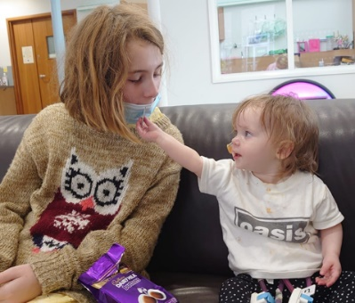

Sarah Grey

Stanley Woodies and The Den

**Beatrix and Eliza’s Story**

One of our Woodcraft Folk members, Eliza aged 12, has a Rainbow Trust Support Worker because her baby sister is in hospital. Beatrix who is 1 needs a new heart. At 15mth old Beatrix suffered heart failure, cardiac arrest and underwent major heart surgery. She has a Berlin heart that keeps her alive until she waits for a new heart to be donated. Beatrix lives at the hospital with her mam, Cheryl.

The Rainbow Trust Support Worker picks Eliza up from school and drops her off. They take her out on a weekend when Eliza is on the ward to give her a break and some normality. They stay with Beatrix on the ward so that Eliza's mam and step-dad, Terry, can take Eliza out for a bit. They are amazing and the funding raised will be used for such a good cause. Please donate all you can.

Rainbow Trust Children’s Charity supports families who have a child with a life-threatening or terminal illness. When a child has a serious illness, family life is turned upside down and time becomes more precious than ever. Rainbow Trust pairs each family with an expert Family Support Worker who enables them to make the most of time together, giving them practical and emotional support, whenever they need it, for as long as is needed. We support the whole family including parents, carers, the unwell child, brothers, sisters and grandparents.

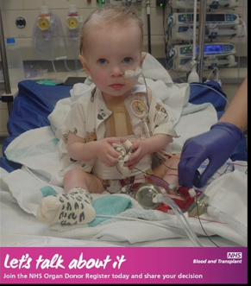

**For more information:**

* Search for BeatrixHeart22 on Facebook and like and share
* Visit <https://www.organdonation.nhs.uk/>
* Visit <https://www.rainbowtrust.org.uk/>

**-------------------------------------------------------------------------------------------------------------------------**

**Sponsored Sleepover – 26 October 2022**

Members Name(s)______________________ ____________________

Group(s) __________________________________________________

Consent form signed Yes/No (this can be done at group night)

I agree that my child will raise the minimum sponsorship: Yes / No

Signed_______________________________ Date _________________

(parent/carer)